**TRAINING REPORT**

on

**New College Website**

Submitted in partial fulfillment of the

Requirements for the award of

**Degree of Bachelor of Engineering in Computer Science & Engineering**



**Submitted By :**

**Name**: Namish Khanna & Mohd. Shakeeb Saleh

**University ID**: 17BCS1884 , 17BCS1869

**Training Group**:13

**SUBMITTED TO:**

**Department of Computer Science & Engineering**

Chandigarh University

Gharuan, Mohali

**ACKNOWLEDGEMENT :**

It is indeed with a great pleasure and immense sense of gratitude that we acknowledge the help of these individuals. We are highly indebted to our Director **Prof. BS SOHI** , **Prof. RS BAWA**, Chandigarh University, for the facilities provided to accomplish this main project.

We would like to thank our, Head of the Department of Computer Science and Engineering CHANDIGARH UNIVERSITY, for this constructive criticism throughout our project We feel elated in manifesting our sense of gratitude tour internal project guide **Prof. Rohit Katyal and Prof. Rubaljit Kaur, Associate Professor, Department of Computer Science and Engineering** CHANDIGARH UNIVERSITY.

He has been a constant source of inspiration for us and we are very deeply thankful to him for his support and valuable advice

We extremely grateful to our Departmental staff members, Lab technicians and Non-teaching staff members for their extreme help throughout our project.

Finally we express our heartful thanks to all of our friends who helped us in successful completion of this project.

**Department of Computer Science & Engineering :**

**CERTIFICATION :**

This is to certify that the dissertation entitled **“ ROCKSTAR UNIVERSITY ”** is submitted by **NAMISH KHANNA (17BCS1884) , SHAKEEB SALEH (17BCS1869)** in their partial fulfillment of the requirement of the award of the degree of *bachelor of technology*, Chandigarh University, Kharar is a record of bonafide work carried out by them under my guidance and supervision. The result embodied in this thesis has not been submitted to any other university or institution for the award of any degree or diploma.

………………… ……………..

Signature of external Signature of Training Teacher examiner

**DECLARATION :**

We hereby declare that project titled **“ROCKSTAR UNIVERSITY”** is a bonafide original record done by us at chandigarh university towards the partial fulfillment of requirement for the award of degree of Bachelor of technology in Computer Science and Engineering during the period of 2018-2019 in **Rockstar University reports**,

**Chapter Scheme :**

**1.** Introduction to Project

**2.** Tools & Technology Used

**3.** Snapshots

**4.**  Results and Discussions

**5.**  Conclusions and Future Scope

**6.** References

**Introduction to Project :**

**\*** The project ‘ Rockstar University ’ includes registration of students to take admission in University ,storing their details into the system, and labs. The websites has the facility to show about the University Infrastructure and Facilities. The site also tells the people about Fees Structure and Programs Used.

**\*** The Rockstar University System can be entered using their details. It is accessible either by an administrator or receptionist. Only they can add data into the database. The data can be retrieved easily. The interface is very user-friendly. The data are well protected for personal use and makes the data processing very fast.

**\*** Rockstar University System is powerful, flexible, and easy to use and is designed and developed to deliver real conceivable benefits to the coaching center.

**\*** Rockstar University System is designed for entering the detalis of students, to cover a wide range of administration and management processes. It is an integrated end-to-end Developer System that provides relevant information across the area to support effective decision making for critical financial accounting, in a seamless flow.

**\*** Rockstar University System is a website product designed to improve the quality and management of other universities the areas of data analysis and activity-based costing. Rockstar University System enables you to develop your organization and improve its effectiveness and quality of work. Managing the key processes efficiently is critical to the success of the coaching center helps you manage your processes.

**TOOLS & TECHNOLOGY USED :**

**\*** The most common set of requirements defined by any operating system or software application is the physical computer resources, also known as hardware. A hardware requirements list is often accompanied by a hardware compatibility list (HCL), especially in case of operating systems. An HCL lists tested, compatibility and sometimes incompatible hardware devices for a particular operating system or application. The following sub-sections discuss the various aspects of hardware requirements.

**HARDWARE REQUIREMENTS FOR PRESENT PROJECT** :

**PROCESSOR**  : Intel dual Core , i3 , Pentium

**RAM**  : 512 MB

**HARD DISK**  : 320 GB

**SOFTWARE REQUIREMENTS :**

Software Requirements deal with defining software resources requirements and pre-requisites that need to be installed on a computer to provide optimal functioning of an application. These requirements or pre-requisites are generally not included in the software installation package and need to be installed separately before the software is installed.

**SOFTWARE REQUIREMENTS FOR PRESENT PROJECT :**

**OPERATING SYSTEM** : Linux

**FRONT END** : HTML , CSS , JAVA SCRIPT.

**SERVER SIDE SCRIPT** : Php

**DATABASE**  : MySql

**SOFTWARE SPECIFICATION :**

**HTML :**

**HTML**  or  **Hypertext Markup Language:** is the standard [markup language](http://en.wikipedia.org/wiki/Markup_language) used to create [web pages](http://en.wikipedia.org/wiki/Web_page).

HTML is written in the form of  [HTML elements](http://en.wikipedia.org/wiki/HTML_element)  consisting of  *tags*  enclosed in [angle brackets](http://en.wikipedia.org/wiki/Angle_brackets)  (like  <html>). HTML tags most commonly come in pairs like <h1> and </h1>, although some tags represent *empty elements*  and so are unpaired, for example <img>. The first tag in a pair is the *start tag*, and the second tag is the *end tag* (they are also called *opening tags* and *closing tags*). Though not always necessary, it is best practice to append a slash to tags which are not paired with a closing tag.

The purpose of a [web browser](http://en.wikipedia.org/wiki/Web_browser) is to read HTML documents and compose them into visible or audible web pages. The browser does not display the HTML tags, but uses the tags to interpret the content of the page. HTML describes the structure of a website [semantically](http://en.wikipedia.org/wiki/Semantic) along with cues for presentation, making it a [markup language](http://en.wikipedia.org/wiki/Markup_language) rather than a [programming language](http://en.wikipedia.org/wiki/Programming_language).

HTML elements form the building blocks of all [websites](http://en.wikipedia.org/wiki/Website). HTML allows [images and objects](http://en.wikipedia.org/wiki/Img_(HTML_element)) to be embedded and can be used to create [interactive forms](http://en.wikipedia.org/wiki/Fieldset). It provides a means to create [structured documents](http://en.wikipedia.org/wiki/Structured_document) by denoting structural [semantics](http://en.wikipedia.org/wiki/Semantic) for text such as headings, paragraphs, lists, [links](http://en.wikipedia.org/wiki/Hyperlink), quotes and other items. It can embed [scripts](http://en.wikipedia.org/wiki/Scripting_language) written in languages such as [JavaScript](http://en.wikipedia.org/wiki/JavaScript) which affect the behavior of HTML web pages.

**CASCADING STYLE SHEETS** (**CSS**) :

It is a [style sheet language](http://en.wikipedia.org/wiki/Style_sheet_language) used for describing the [look and formatting](http://en.wikipedia.org/wiki/Presentation_semantics) of a document written in a [markup language](http://en.wikipedia.org/wiki/Markup_language). While most often used to style [web pages](http://en.wikipedia.org/wiki/Web_page) and [interfaces](http://en.wikipedia.org/wiki/Interface_(computing)) written in [HTML](http://en.wikipedia.org/wiki/HTML) and [XHTML](http://en.wikipedia.org/wiki/XHTML), the language can be applied to any kind of [XML](http://en.wikipedia.org/wiki/XML) document, including [plain XML](http://en.wikipedia.org/wiki/Plain_Old_XML), [SVG](http://en.wikipedia.org/wiki/Scalable_Vector_Graphics) and [XUL](http://en.wikipedia.org/wiki/XUL). CSS is a cornerstone specification of [the web](http://en.wikipedia.org/wiki/The_web) and almost all web pages use CSS style sheets to describe their presentation.

CSS can also allow the same markup page to be presented in different styles for different rendering methods, such as on-screen, in print, by voice (when read out by a speech-based browser or [screen reader](http://en.wikipedia.org/wiki/Screen_reader)). It can also be used to allow the web page to display differently depending on the screen size or device on which it is being viewed. While the author of a document typically links that document to a CSS file, readers can use a different style sheet, perhaps one on their own computer, to override the one the author has specified. However if the author or the reader did not link the document to a specific style sheet the default style of the browser will be applied.

**MySQL :**

MySQL is developed, distributed and supported by Oracle Corporation. MySQL is a database system used on the web it runs on a server. MySQL is ideal for both small and large applications. It is very fast, reliable, and easy to use. It supports standard SQL. MySQL can be compiled on a number of platforms.

The data in MySQL is stored in tables. A table is a collection of related data, and it consists of columns and rows. Databases are useful when storing information categorically.

**FEATURES OF MySQL :**

**Internals and portability :**

1. Written in C and C++.
2. Tested with a broad range of different compilers.
3. Works on many different platforms.
4. Tested with Purify (a commercial memory leakage detector) as well as with Val grind, a GPL tool.
5. Uses multi-layered server design with independent modules.

**JAVASCRIPT :**

JavaScript is the scripting language of the Web. All modern HTML pages are using JavaScript. A scripting language is a lightweight programming language. JavaScript code can be inserted into any HTML page, and it can be executed by all types of web browsers. JavaScript is easy to learn.

**WHY TO USE JAVASCRIPT** :

JavaScript is one of the 3 languages all web developers  must learn:

1. HTML to define the content of web pages
2. CSS to specify the layout of web pages
3. JavaScript to specify the behavior of web pages

**Example:** x = document.getElementById("demo");  **//Find the HTML element with id="demo"**

x.innerHTML = "Hello JavaScript";   **//Change the content of the HTML element**

**document.getElementById()** is one of the most commonly used HTML DOM methods.

**JAVASCRIPT CODE :**

* JavaScript code (or just JavaScript) is a sequence of JavaScript statements.
* Each statement is executed by the browser in the sequence they are written.
* This example will manipulate two HTML elements:
* Example
* document.getElementById("demo").innerHTML="Hello Dolly";  
  document.getElementById("myDIV").innerHTML="How are you?";

**……………………...**

**PHP :**

**WHAT IS PHP ?**

* PHP is an acronym for "PHP Hypertext Preprocessor"
* PHP is a widely-used, open source scripting language
* PHP scripts are executed on the server
* PHP costs nothing, it is free to download and use

**WHAT IS PHP FILE ?**

* PHP files can contain text, HTML, CSS, JavaScript, and PHP code
* PHP code are executed on the server, and the result is returned to the browser as plain HTML
* PHP files have extension ".php"

**WHAT CAN PHP DO ?**

* PHP can generate dynamic page content
* PHP can create, open, read, write, delete, and close files on the server
* PHP can collect form data
* PHP can send and receive cookies
* PHP can add, delete, modify data in your database
* PHP can restrict users to access some pages on your website
* PHP can encrypt data

**WHY PHP ?**

* PHP runs on various platforms (Windows, Linux, Unix, Mac OS X, etc.)
* PHP is compatible with almost all servers used today (Apache, IIS, etc.)
* PHP supports a wide range of databases
* PHP is free. Download it from the official PHP resource: [www.php.net](http://www.php.net/)

**SAMPLE SNAPSHOTS**

**…………………………………**

**HOME PAGE:**



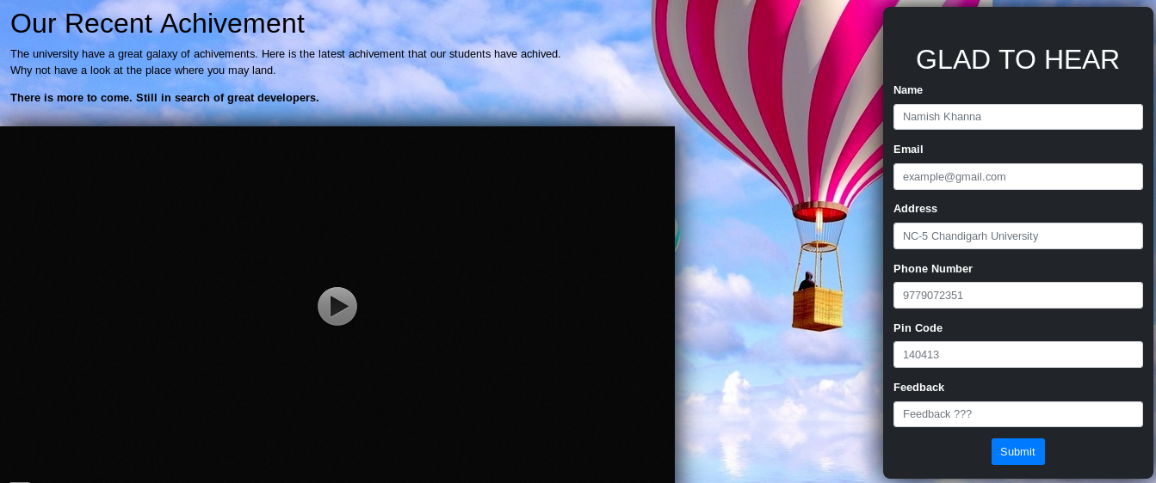

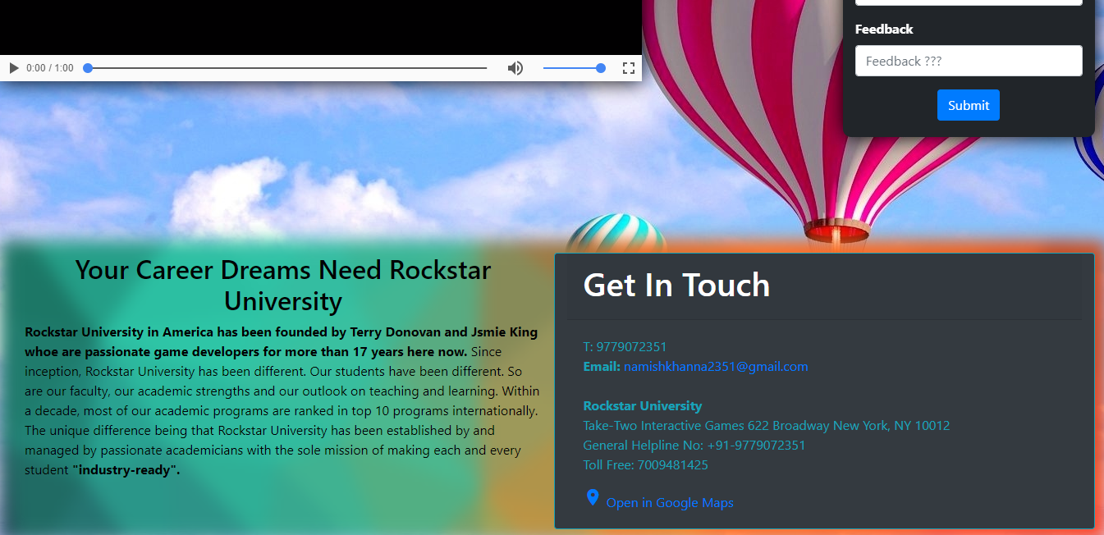

**Computer Science Engineering :**

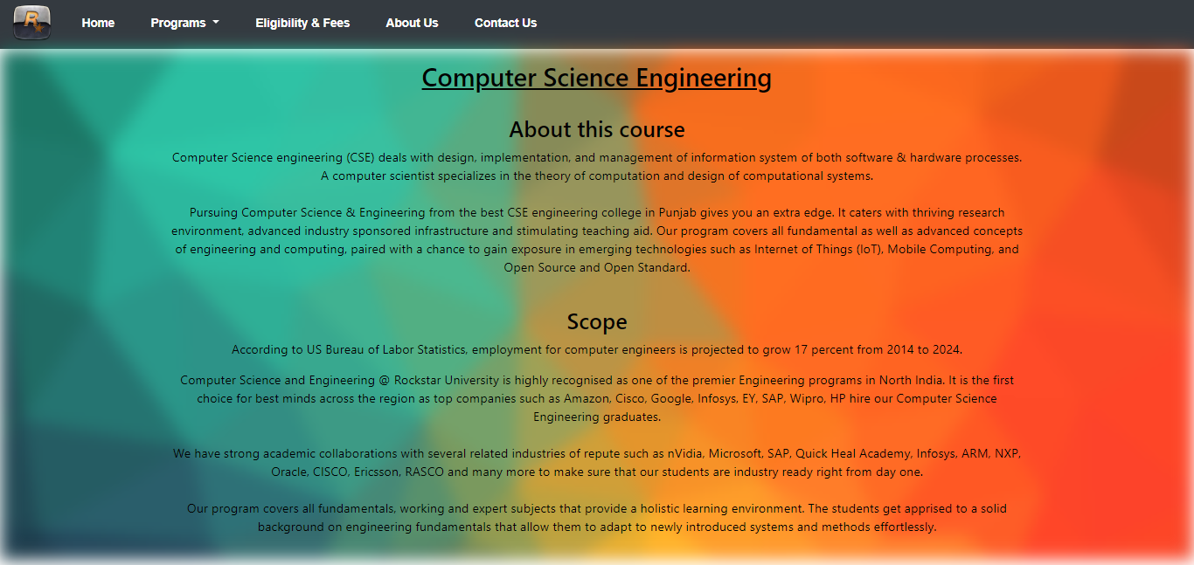

**Mechanical Engineering :**



**Electrical Engineering :**



**Automobile Engineering :**

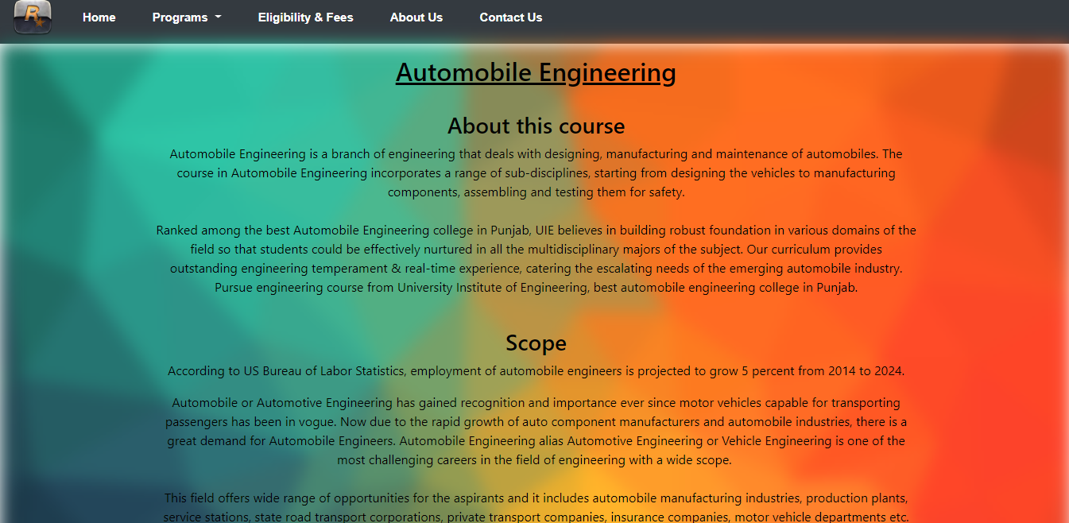

**Eligibility & Fees Details :**

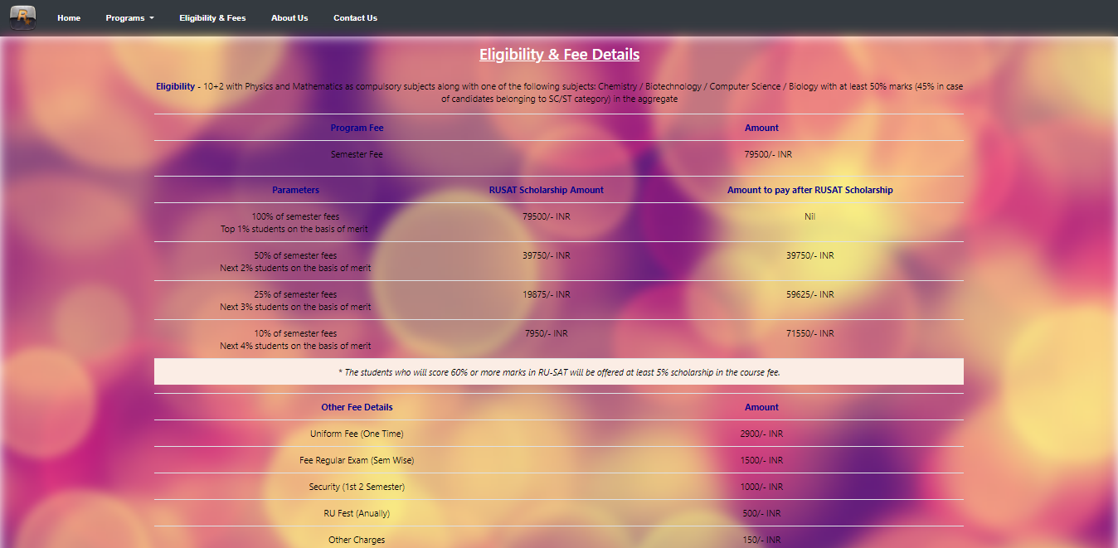

**About The University :**

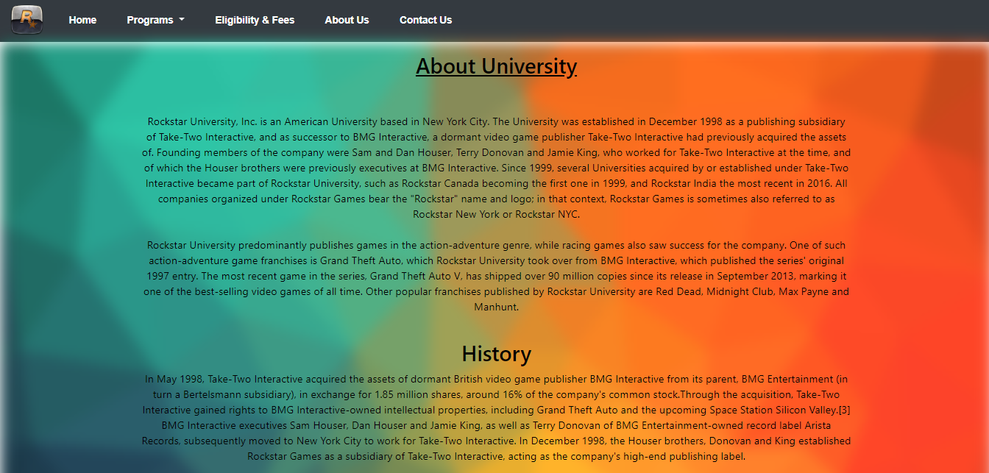

**DataBase :**

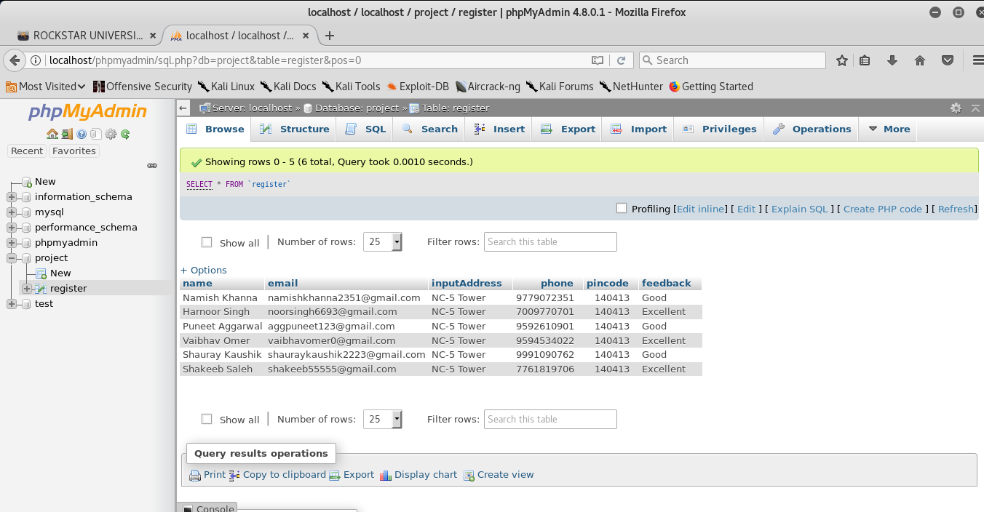

**RESULT AND DISCUSSIONS :**

## 

An online questionnaire was prepared along with hands on testing of the application to judge the success of the application. No major issues were found with the results of users' feedback. This feedback showed that everyone had found the application to be very much useful in analysing historical change. Every participant agreed that the application can be easily navigated and was quite easy to handle and operate. Overlay technique was much preferred by the users over the Series to analyze the historical change. However, some of the participants were not satisfied with the scale of the maps used. A few user interface issues were also faced and raised by the users which are expected to be delievered in the future release. On the whole, an appreciative attitude was observed towards using the application in spite of some above mentioned critical comments.

**CONCLUSIONS AND FUTURE SCOPE :**

**Conclusion:** The whole systems activities are divided into three major parts like students, teachers and admin. Each one has their own role to perform and system respond accordingly. Several agents have been created using web services and inter agent communication is done. Ontologies in form of xml are used for storing information. Different ontologies have been created for different purpose. For implementing the system .Net technologies like ASP.Net, C#, jQuery, Ajax, CSS are used. Current Dialog Student conversation and News part are dynamic and it is a part of Content Management System (CMS). Some parts used CMS concept and works exactly like them. In CMS also xml files are used for managing the states and information. In this system ontology plays similar role.

The system comprise of following features.

• Management of Teachers

• Management of Students

**Future scope :**There are also few features which can be integrated with this system to make it more flexible. Below list shows the future points to be consider.

• Directly getting the admission through this website.

• Online Payment method for fees.

• Online lectures facilities for remote areas for students.

**…………………………………………………………..**

**REFERENCES :**

* <http://www.w3.org/TR/html5>
* <https://html.spec.whatwg.org/multipage/index.html>)
* <http://www.w3.org/TR/CSS21/>
* <https://developer.mozilla.org/en-US/docs/Web/JavaScript>.
* [http://api.jquery.com](http://api.jquery.com/).
* <http://php.net/>
* [http://www.mysqltutorial.org](http://www.mysqltutorial.org/).

**……………………………………………………..**

**……………………………………………………**